Registration From webpage



# Technology for frontend

* HTML
* CSS

Technology for Backend

* NodeJS

Technology for Database

* MongoDB

Landing Page

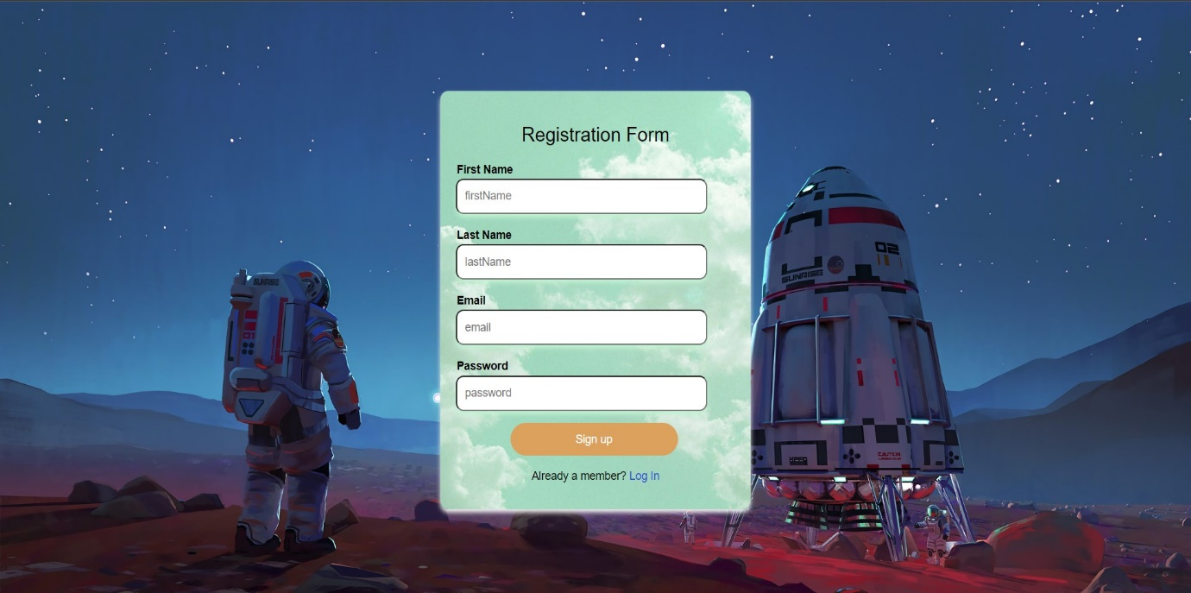User will input their credential here for registration

Successful Page

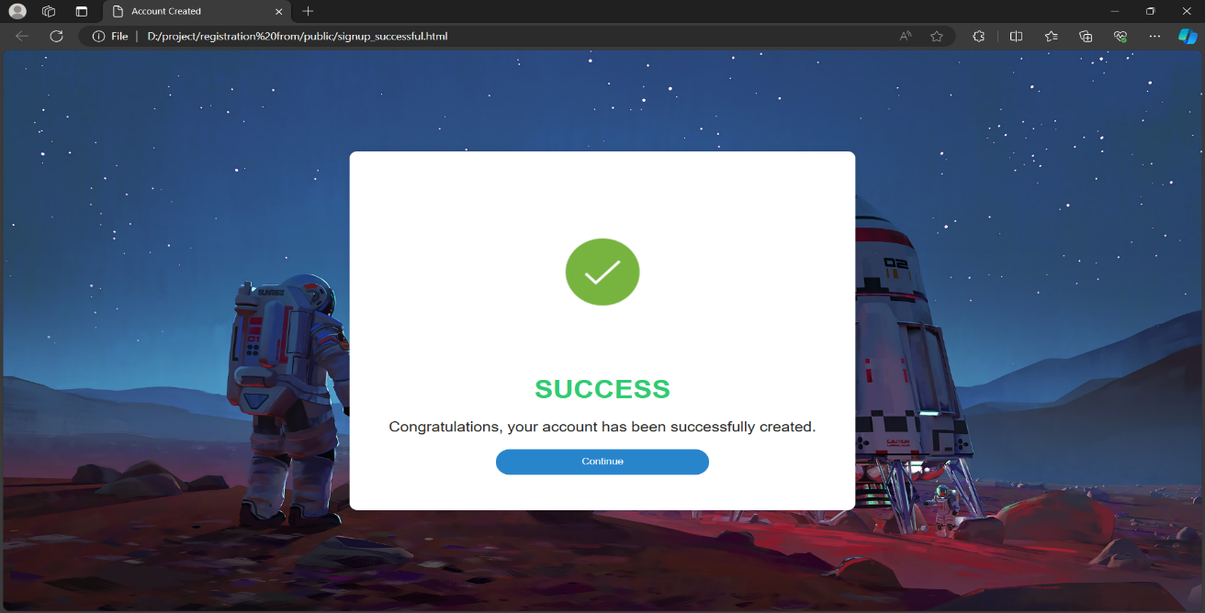

Backend

Dependence for Running the application

* nodemon 3.1.0
* body-parser 3.1.0
* Express 4.18.3
* Mongoose 8.2.1

Commands for running the web application

* To initialize the dependence

$ - npm init

* To install the dependence

$ - npm install express mongoose body-parser express mongoose nodemon

* To run the server

$ - node index.js

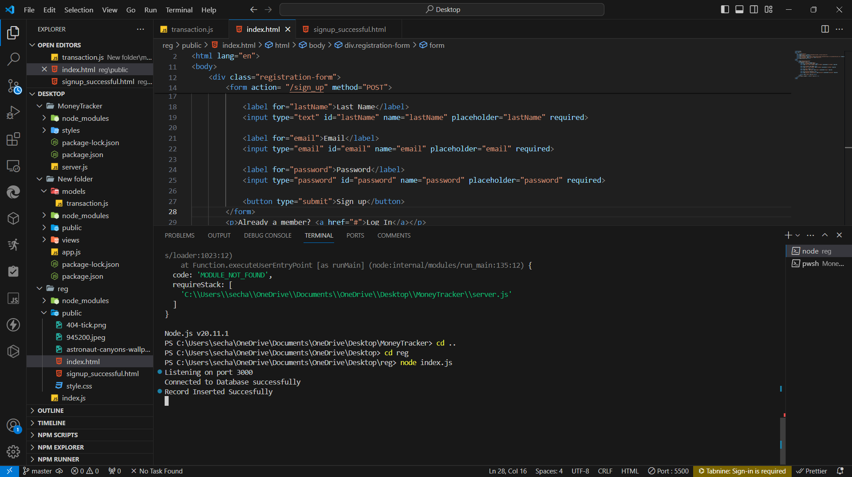 Server runs in port number localhost:3000

It reflects listening on port 3000 then we can run our web application

* Connect to the MongoDB for connect to Database (mongodb://localhost:27017/Database) 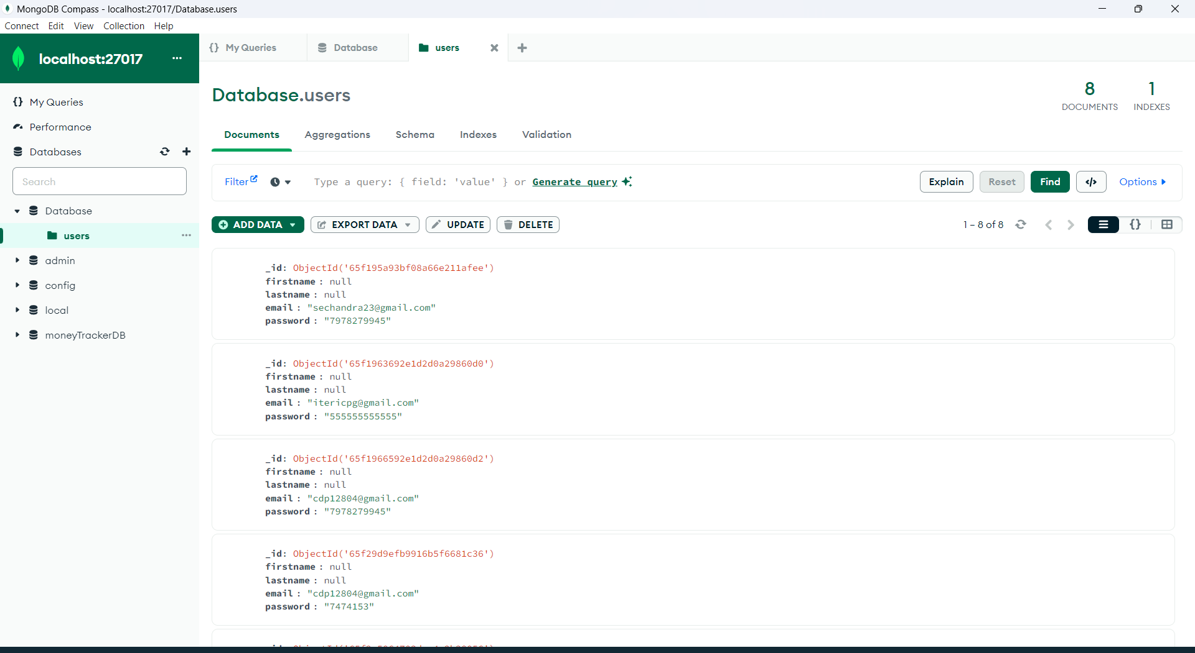 After inserting the data in frontend page, it will store in above database file.

Conclusion

After starting the server, we can access the page in (https://localhost:3000). Then we will insert our registration credential in the form after submitting the form it will store the credentials in the MongoDB database(mongodb://localhost:27017/Database),

Then a successful page appears.